

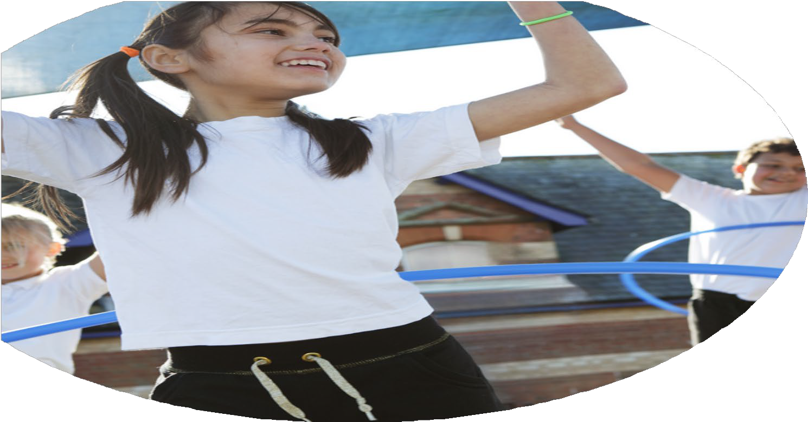
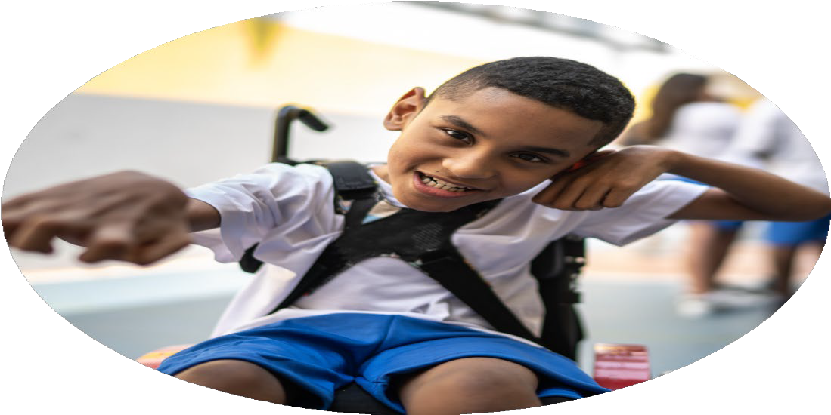
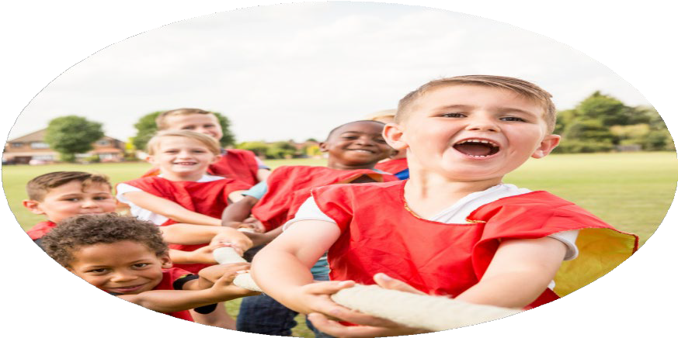



PE Funding

Evaluation Form

Chagford Church of England Primary School

2025/26 Evaluation

Commissioned byDfE

Created by James Green – Headteacher

PE Funding Evaluation Form

It is intended that this template should be used as preparation for the completion of the statutory digital reporting tool being introduced this academic year. You can upload data (including swimming) from this template onto this platform once it becomes accessible.
Before you decide how you are going to use the funding for this academic year you should reflect and evaluate the impact of your use of the funding in 2025/26.
All spending of the funding must conform with the terms outlined in the Conditions of Grant document. The template is a working document that you can amend/update during the year.
Based on your evaluation of last year’s funding you should decide what you intend to do this academic year, how you will do it, and what impact you expect it to have.

It is important that the funding is used effectively and based on your school’s needs.
You must use the funding to make additional and sustainable improvements to the PE and sport in your school. You must develop and add to the PESSPA activities that your school already offers.

Summative digital reporting from June 2026 will continue to include swimming and water safety information, therefore funding can be used to provide top-up lessons where necessary to ensure pupils meet national curriculum swimming requirements.

Spending breakdown:
Total Amount carried over from 2024 – 2025 £0
Total Amount allocated for 2025 - 2026 £17,140
How much (if any) do you intend to carry over from this total fund to 2026 - 2027 £0
Total Amount for 2026 - 27 £11,486 (50% in autumn term and 50% in 2027)

What went well? | How do you know? | What didn’t go well? | How do you know? | Summary of spending
Resources were purchased to enhance playtimes - This will remain a priority for next year especially for younger children in Year 2.  Sports Day was a huge success, with the whole school participating in a range of inclusive and competitive elements. This is working well and will continue. We will run this in the same format next year.  Sports clubs afterschool to encourage wider participation in physical exercise and a wider experience of activities  Bike Ability so that all children in Year 6 can ride a bike safely. 90% of Y6 children left school able to swim 25 metres confidently. Sport leader facilitated games and sports during lunchtimes for younger children.  PE equipment to use for PE sessions, clubs and active playtimes.  Outdoor and adventurous activities encourage wider participation in physical exercise and a wider experience of activities, especially being so close to Dartmoor.  Saints Southwest Sports Coaches provide specialist coaching across a range of sports for all classes across the school.  Teachers observe throughout the year as part of their PE CPD. Use of Oak Academy membership to increase the quality and standard of PE teaching across school.  Oak Academy is designed to be fully inclusive, taking away some of the stigmatism associated with certain sports.  OCRA membership to provide various sporting festivals and competitions across the school give every pupil the opportunity to experience a wide range of sports. | 90% of Y6 children left school able to swim 25 metres confidently.  Positive feedback from parents, staff and children.  Sports clubs were popular throughout the year: cross country, tag rugby, netball, football.  Most Year 6 children learned to ride their bicycle safely and confidently.  Increased engagement of all pupils in regular physical activity | There is limited available evidence showing how Sports Premium spending has directly impacted pupil outcomes (e.g., fitness levels, participation rates, or skill development).  Staff CPD and Confidence: If staff confidence in delivering high-quality PE is not consistently strong, this could limit the effectiveness of the funding. More targeted CPD and lesson modelling may be needed.  Sustainability of Improvements: Reflect how investments (e.g., equipment, coaching) will benefit future cohorts, not just current pupils.  Extracurricular Access: There’s no clear indication of how extracurricular sports are being expanded or made accessible to all pupils, especially those from disadvantaged backgrounds. | Staff Feedback: Are teachers confident in delivering high-quality PE? Do they feel supported by CPD? Staff have indicated they need more training.  Pupil Voice: What do pupils say about PE and sport? Are they engaged and enthusiastic? More pupil voice is needed in this area.  Participation Rates: Are all pupils, including those with SEND or from disadvantaged backgrounds, participating equally? A review is needed around vulnerable groups. | Total school spending on external activities £4678  Total internal category spend £3429  Total CPD category spend £9033  Total spend: £17140

What are your plans for 2026/27? | How are you going to action and achieve these plans?
Intent | Implementation
- Increasing staff confidence, knowledge and skills in PE.  - Increasing engagement of all pupils in regular physical activity.  - Raising the profile of PE and sport across the school.  - Providing a broader range of sporting opportunities.  - Increasing participation in competitive sport. | To organise swimming lessons with qualified swimming coaches for Year 3 to Year 6 pupils in the Summer Term.  Encourage individuals and their families to sign up to the local swim school lesson (verbally 1:1 to those children not meeting expected standard and generally via school newsletter).  Arrange after school sport – competitive matches in mixed netball and football.  Sign up to OCRA events – calendar of sporting events and competitions run throughout the year. In house designed around all participating, sportsmanship and achieving with healthy competition.  Audit and order of playground and PE resources  Review and develop a PE curriculum that meets the schools specific needs and offers a variety of sports and activities for all using Oak Academy Resources.

What impact/intended impact/sustainability are you  expecting? | How will you know? What evidence do you have or  expect to have?
By the end of Year 6 the aim is for every pupil to be able to perform safe self-rescue in different water based situations.  Swim competently, confidently and proficiently over a distance of at least 25 metres.  Use a range of strokes effectively, for example, front crawl, backstroke and breaststroke.  Sports Coaching – lunchtime and afterschool  Inter-Hub Sport Inter – School competitions run by OCRA  School Sports Day Sports Equipment – increase pupil engagement and variety of sports/activities we can offer.  PE Curriculum Development | We will gather information on pupils swimming ability and work out what % of pupils have met these standards.  Broader experience of a range of sports and activities offered to all pupils. Increased engagement of all pupils in regular physical activity Full engagement and participation in course by Year 6 pupils.  Several of these matches took place throughout the year. Feedback was positive. Parents/families came to support. High level of engagement from pupils.  Took part in three Cross Country events Festival Successful day - focus on sportsmanship, taking part and having fun.  Replace old equipment, ensure a variety of equipment to cater for all ages and abilities.  A PE curriculum has been produced and implemented that meets the schools specific needs and offers a variety of sports and activities for all.  Opportunities have been tailored to meet the pupils needs. Encouraged via school newsletter

What impact/sustainability have you seen? | What evidence do you have?
Year 3 - 6 completed their 6-week block of swimming lessons.  Using Okehampton College minibuses has made the transport financially sustainable.  Bikeability is sustainable.  Inter-Hub Sport – School competitions run by OCRA subscription  School Sports Day - same format as last year – re-use equipment, keep resources for future years.  Sports Equipment – increase pupil engagement and variety of sports/activities we can offer. | What percentage of pupils in your current year 6 cohort can swim competently, confidently, and proficiently over a distance of 25 metres?  90%  What percentage of pupils in your current year 6 cohort can use a range of strokes effectively (e.g. front crawl, backstroke, and breaststroke)? 90%  What percentage of pupils in your current year 6 cohort can perform safe self-rescue in different water-based situations? 90%  Participation and completion of course by all Year 6 pupils Several of these matches took place throughout the year. Feedback was positive.  Parents/families came to support. High level of engagement from pupils.  Positive feedback from parents, children and staff. New equipment purchased – enabled more variety in the PE offer and engagement from pupils.  All pupils have received a wide and varied curriculum and been able to progress

