Relationship, Sex and Health Education Policy: Chagford Church of England School
Our school’s approach to Relationship, Sex and Health Education (RSHE) follows that of the Church of England Education Office in that it seeks to be faith-sensitive and inclusive.
At Chagford Church of England School, everyone will be treated with dignity as all people who are made in the image of God and are loved equally by God.
All pupils have a right to an education which enables them to flourish and is set in a learning community where differences of lifestyle and opinion (within that which is permissible under UK law) are treated with dignity and respect; where bullying of all kinds is eliminated; and where they are free to be themselves and fulfil their potential without fear.
Our school seeks to ensure that the RSHE curriculum protects, informs and nurtures all pupils. It clearly differentiates between factual teaching (biology, medicine, the law, marriage, different types of families and the composition of society) and moral teaching about relationships and values, recognising that the distinction can be easily blurred and that there needs to be discernment about the manner in which this is taught. We teach RSHE within a moral (but not moralistic) framework.
RSHE in Chagford Church of England School is about what constitutes wellbeing and loving care for ourselves (physical and mental health education), how we show loving care for others (relationships education) and, when at an appropriate age and stage in life, how we show loving care to those we choose to be intimate with, including within marriage and other committed, loving relationships (sex education).
It is also about the spiritual and moral aspects of healthy, loving and nurturing relationships within the context of a Christian vision for the purpose of life and within other faith and non-faith understandings of love and commitment.
Pupils will consider how to ensure that they treat themselves and others, at all times and in all contexts, with dignity and respect.
Defining Relationships Education
Relationships Education is learning about how to:
- be appreciative of existing relationships;
- form new healthy friendships; and
- enjoy strong positive, caring, relationships with good boundaries, online and in person.
This will particularly refer to family relationships, partnerships, friendships and relationships with peers and adults.
Defining sex education
Sex education is about reproduction: learning how babies can be made and the emotions that people experience when they are ready for close intimacy.
The national curriculum for science includes content about human body parts, growth, puberty and gestation. Parents do not have the right to withdraw from this aspect of the curriculum.
In this school we have decided that it is important to include sex education to educate the children in our community for adulthood (and for secondary school) in their last year of primary school.

The right to withdrawal from sex education
Parents do have the right to excuse their children from this aspect of RSHE and can do so by making concerns known and applying in writing to the Headteacher. The school will invite any enquiring parents or legal guardians to talk through concerns. An explanation of the rationale for RSHE will be given; an opportunity will be offered to review the intended materials and to consider the impact of not receiving sex education with peers.
Withdrawing a child from sex education remains a statutory right as a parent or legal guardian. If a pupil is excused from sex education it is the school’s responsibility to ensure that the pupil receives appropriate, purposeful education during the period of withdrawal. There is no right to withdraw from relationships education or health education.
The school will document this process to ensure a record is kept.
Defining health education
Health education is learning about physical health and mental wellbeing so that pupils can make wise choices to ensure their own flourishing and the flourishing of others.
The RSHE Curriculum
At Chagford Church of England School we teach:
About families and about people who care for us as a foundation to learn about respectful caring relationships and about the diversity of forms of family.
About the caring relationships including family relationships and friendships. We teach that friendships can have ups and downs but remain friendships and that we can learn skills to make our relationships more sustainable.
About respect including respect for ourselves, about manners and conventions that make relationships easier to maintain, about bullying and stereotypes.
We learn about online relationships and how we can keep ourselves safe in online relationships.
We learn about respect for our bodies and our boundaries and about consent and how this can help keep us safe and allow us to maintain positive, sustainable relationships of all sorts. We learn how to report concerns and how to ask for advice.
These are the requirements for RSHE from the Department for Education [click here]
How will RSHE be taught in our school?
RSHE will be delivered professionally and as an identifiable part of PSHE. It will be led, resourced and reported to parents in the same way as any other subject. There will be a planned programme delivered in a carefully sequenced way.
RSHE will be delivered in a way that affords dignity and shows respect to all who make up our diverse community. It will not discriminate against any of the protected characteristics in the Equality Act and will be sensitive to the faith and beliefs of those in the wider school community. RSHE will seek to explain fairly the tenets and varying interpretations of religious communities on matters of sex and relationships and teach these viewpoints with respect. It will value the importance of faithfulness as the underpinning and backdrop for relationships. It will encourage pupils to develop the skills needed to disagree without being disagreeable, to appreciate the lived experience of other people and to live well together.
RSHE will seek to build resilience in our pupils to help them form healthy relationships, to keep themselves safe and resist the harmful influence of the excesses of media in all its forms.
RSHE will promote healthy resilient relationships set in the context of character and virtue development that sits within the schools Christian Vision and Values and which accord with the values of the diverse stakeholder community.
Values such as such as Hope, Respect, Courage, Kindness, Honesty and Curiosity.
All staff teaching this sensitive and important subject will have received training. This training will be regularly reviewed and revisited.
Pupils with SEND will have had the content made accessible to them through whatever means makes it best available to them. This may include one to one teaching, the use of differentiated resources or work alongside parents and carers.
At Chagford Church of England School RSHE is taught by confident trained staff and only some elements will be taught by outside agencies (such as First Aid or aspects about puberty). It is important that pupils have confidence in the teacher and that a ‘safe space’ is created where pupils feel confident and can ask age-appropriate questions.
RSHE will be monitored and evaluated
This will follow the same monitoring and evaluation processes used throughout the school for other subjects i.e. pupil conferencing, work reviews, learning walks etc.
Policy Review
This policy has been produced by consultation with the Diocese of Bristol and in consultations with Governors, parents and pupils.
It has been produced in consultation with parents and will be reviewed in consultation with parents. It must, however, be recognised that the law specifies that what is taught and how it is taught is ultimately a decision for the school.
Policy agreed July 2021
This policy will be reviewed every: two years
It is due to be reviewed again on: July 2023
It was approved by FGB on: [date]
Date for review process to begin: [date]
Date for final review to FGB: [date]
This policy should be read in conjunction with The Equalities Act 2010 https://www.gov.uk/guidance/equality-act-2010-guidance

Appendix One:
Chagford Primary School PHSCE Curriculum as at June 2021
N:B: From September 2021 we will be moving to the ‘SCARF’ Curriculum created by Coram.

Personal, Social, Health and Economic (PSHE) Education
Personal, Social, Health and Economic Education is not a subject within the new curriculum. However:​
‘All schools should make provision for personal, social, health and economic education (PSHE), drawing on good practice.’ (2.5 National Curriculum)
‘Every state-funded school must offer a curriculum which is balanced and broadly based and which promotes the spiritual, moral, cultural, mental and physical development of pupils at the school and of society and prepares pupils at the school for the opportunities, responsibilities and experiences of later life’ (2.1 National Curriculum).
​At Chagford CE Primary School:
- PHSE teaching occurs through carefully planned opportunities and incidental opportunities that arise.
- Our planning provides a ‘spiral programme’ which introduces new and more challenging learning, while building on what has gone before, which reflects and meets the personal developmental needs of the children and young people.
- We take a positive approach which focuses on what children can do to keep themselves and others healthy and safe and to lead happy and fulfilling lives.
- We offer a wide variety of teaching and learning styles within PSHE education, with an emphasis on interactive learning and the teacher as facilitator.
- We provide information which is realistic and relevant and which reinforces positive social norms.
- We encourage young people to reflect on their learning and the progress they have made, and to transfer what they have learned to say and to do from one school subject to another, and from school to their lives in the wider community.
- PSHE education is embedded within other efforts to ensure children and young people have positive relationships with adults, feel valued and those who are most vulnerable are identified and supported.
- We provide opportunities for children and young people to make real decisions about their lives, to take part in activities which simulate adult choices and where they can demonstrate their ability to take responsibility for their decisions.
- We provide a safe and supportive learning environment where children can develop the confidence to ask questions, challenge the information they are offered, draw on their own experience, express their views and opinions and put what they have learned into practice in their own lives.

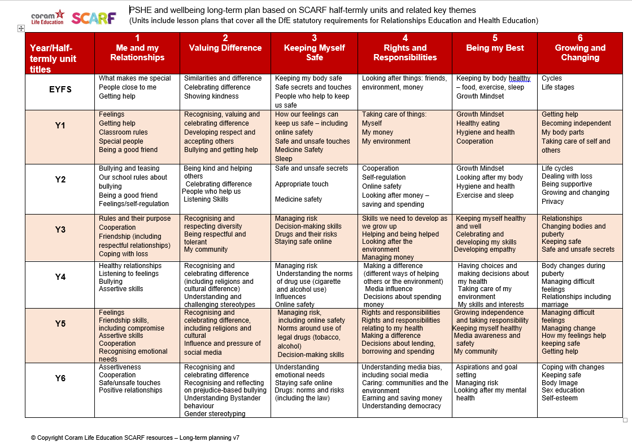

Appendix Two: Parents’ Withdrawal Form

To be completed by parents
Name of child |  | Class
Name of parent |  | Date
Reason for withdrawing from sex education within relationships and sex education
Any other information you would like the school to consider
Parent signature

To be completed by the school
Agreed actions from discussion with parents

See Mental Health and Wellbeing: Towards a Whole School Approach (March 2018)
It does not need to be the class teacher or tutor who teaches Relationships [and Sex] Education. It is best delivered by teachers who are skilled and confident at managing sensitive issues and are good at handling class discussion. See research from Bristol University about secondary RSE https://bmjopen.bmj.com/content/7/5/e014791

