English – 05.01.21
This term, our topic is the Anglo-Saxons – they were the people living in Britain after the Romans left. This half term, we are going to be learning about a very famous Anglo-Saxon story called ‘Beowulf’.
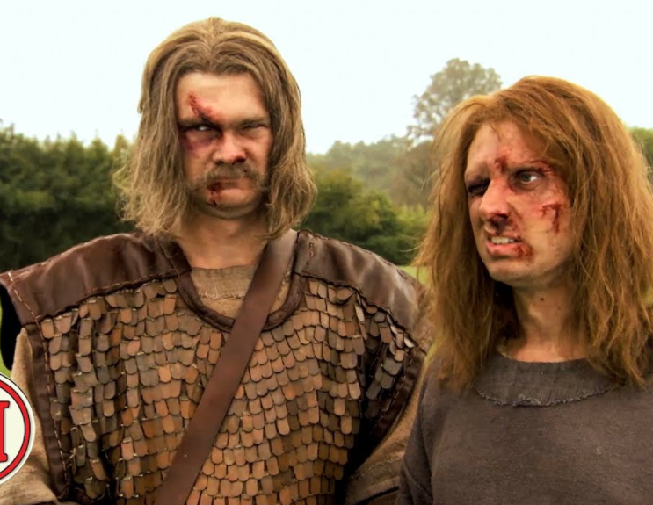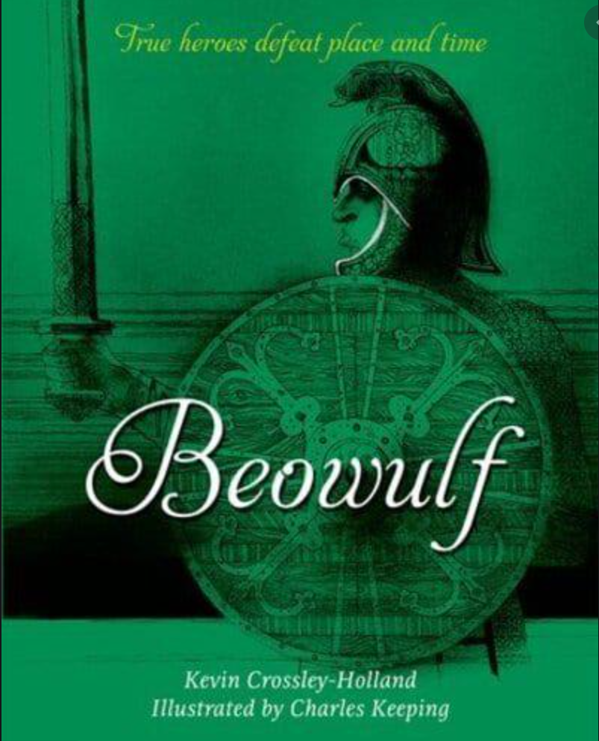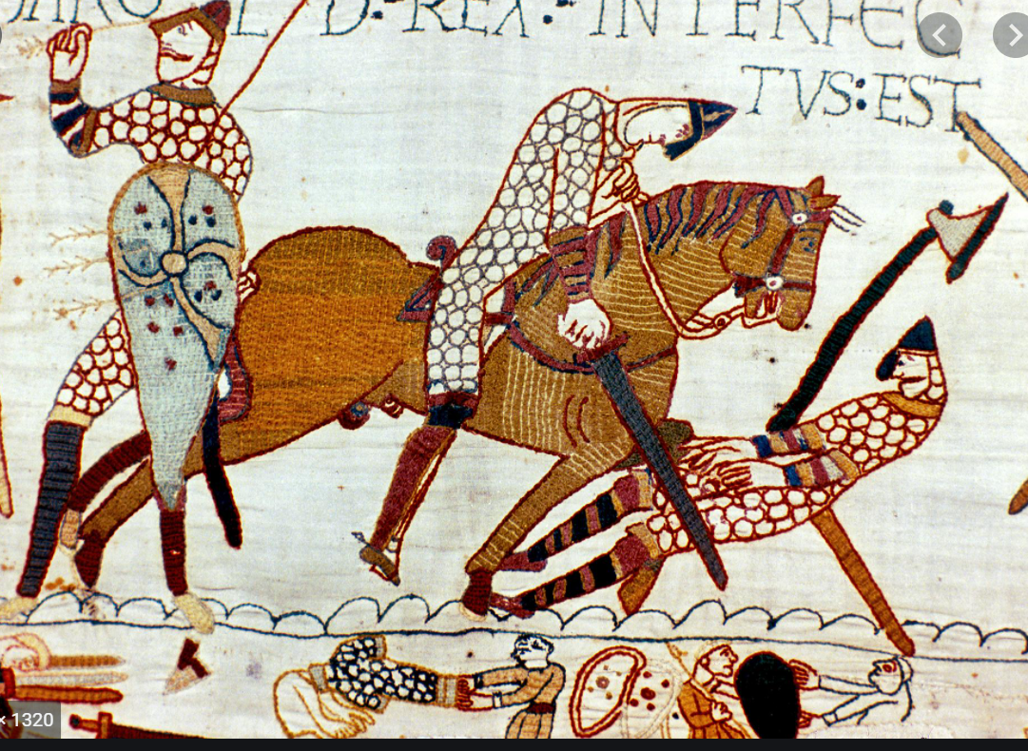
Activity
1) Watch the story of Beowulf on the BBC Teach website: https://www.bbc.co.uk/teach/school-radio/english-ks2-ks3-beowulf-index/zfbhpg8
This is split into 3 episodes that take about 15 minutes in total to watch.
You then have a choice...
2) Make a comic strip, re-telling the story! You can include speech bubbles, small boxes of description and you can make up what the characters look like without worrying about being the same as the video.
OR
3) Draw a detailed illustration of one of the scenes from the story. Be sure to include all the characters and think about the ‘mood’ of the picture e.g) facial expressions, what the weather is like, what sorts of colours to use...

A little help: On the BBC Teach website is a selection of pictures that you can look at to remind you of what happens:
http://teach.files.bbci.co.uk/schoolradio/english/beowulf/beowulf_sequencing_activity.pdf

